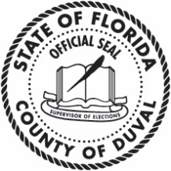
Supervisor of Elections
Duval County, Florida

REMOVAL OF VOTER’S NAME

Please remove my name from the voter rolls:

Voter Information
Last Name | First Name | Middle Name | Suffix
*Date of Birth (MM/DD/YYYY) | Florida Voter Registration System (FVRS) Number (If Known)
*Last Four Digits of Voter’s Social Security Number | *Voter’s Fla. Driver License # or Fla. Identification Card #
Duval County Address

City |  | Zip

*Required

By signing this form, I give the Duval County Supervisor of Elections
consent to remove my name from the voter rolls.

Signature

Voter’s Signature or Mark

POWER OF ATTORNEY NOT ACCEPTABLE
Date

Mail, fax, or scan & email this completed and signed form to:

Supervisor of Elections
105 East Monroe Street
Jacksonville, FL 32202

PHONE: (904) 255-3442
FAX: (904) 255-3434

c:\users\rturner\desktop\september 2017\removal of voters name.docx REV 2/2017
PCarter@coj.net

